Frame 01-04.02:
http://eportal.education2020.com/Curriculum/Production Library/frame-building-files/common/interactiveFrames/intervention/01-04/leftPanelTestFrame01-04.02.html
Step 1
Look at the model, the total tiles in the large rectangle represents the first number in the problem and a group has the same number of tiles as the second number in the problem.
Example: 12 $÷$ 3
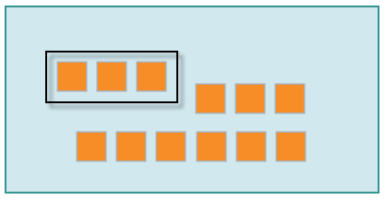
(Image Name: 12!3_Dividing_Model)
Step 2
You will be dividing, which is like repeated subtraction. Drag each group from the model to the white space above to represent repeated subtraction until no groups remain in the large rectangle.
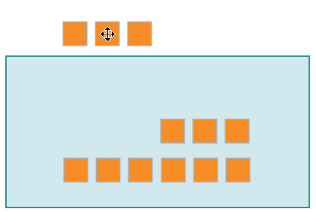
(Image Name: Repeated_Subtraction)
Step 3
When you finished removing all groups, count the number of groups removed from the model. The total number of groups removed represents the quotient.
Example: The quotient of 12 $÷$ 3 is 4 since 4 groups of 3 were subtracted out to get to 0.
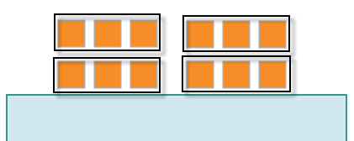
(Image Name: Quotient)

