Frame 1-11.01
Step 1
Look at the model. Whole number place values are shown from ones to thousands.
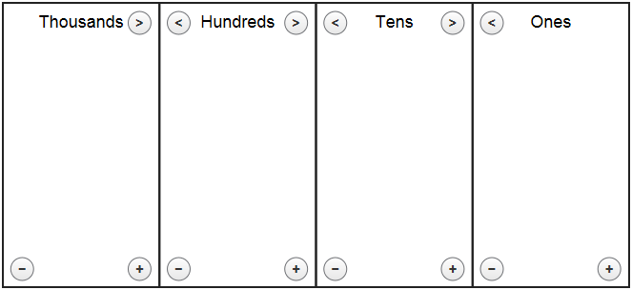 OR
(Image Name: Model_Board)

Step 2
Use the + and - buttons to add or remove base ten blocks in each place value.
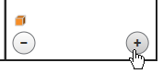 OR 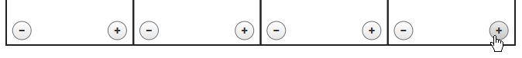 OR
(Image Name: +and-_blocks) (Image Name: add_subtract_unit_blocks)
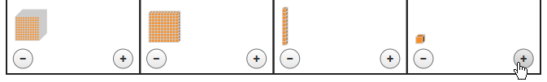
(Image Name: base_ten_blocks)

Step 3
Use the < button to combine blocks to create a bigger unit and > to break a unit into smaller pieces.
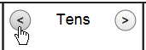 OR
(Image Name: regroup_arrows) (Image Name: all_regroup_arrows)

Step 4 (Couldn’t think of an image for the first sentence, so thought to show an example. Is that okay/helpful?)
Model the value of each digit using the base ten blocks. For example, 341 is modeled.
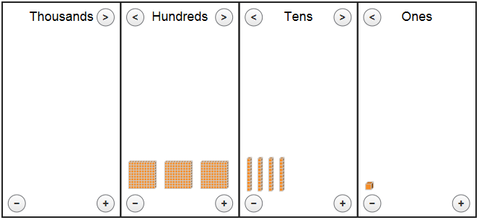
(Image Name: 341_example)

Step 5 (MAYBE Include?)
Tap or click “check” to see the place values that model each digit correctly.
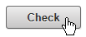
(Image Name: check_button)

Frame 1-11.02
Use same steps as above of 1, 2, 3, and 5.
I think it is best to remove step 4 that’s above from this help because students are not given a number to model for this instead given 2 thousands blocks, 2 hundreds blocks, and 10 ones blocks. Or maybe it’s okay to stay….

