Frame 01-19.01
Note: This frame has instructions appearing!

Step 1
Use the + and - buttons to create 4 groups.
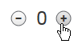
(Image Name: plusminus)

Step 2
Drag an equal amount of hundreds blocks into each blue box.
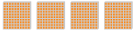
(Image Name: hundredsblocks)

Step 3
Drag an equal amount of tens blocks into each blue box.
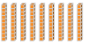
(Image Name: tensblocks)

Step 4
Tap or click the > button to break a tens block into 10 ones blocks.
(Image Name: ungroupten)

Step 5
Drag an equal amount of ones blocks into each blue box. Left over ones blocks is the remainder.
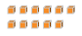
(Image Name: onesblocks)

Step 6
The sum of the blocks in one blue box and the sum of the remainder blocks represents the quotient.

*Possibly combine steps 2 and 3 into one step instead of separate steps, creating 5 steps total of the help.
Step 2
Drag an equal amount of hundreds and tens blocks into each blue box.

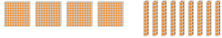
(Image Name: hundredsandtens)

Frame 01-19.02
Note: This frame has instructions appearing!

Step 1
Use the + and - buttons to create 5 groups.
(Image Name: plusminus)

Step 2
Drag an equal amount of thousands blocks into each blue box.
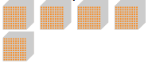
(Image Name: thousandsblocks)

Step 3
Tap or click the > button to break the tens blocks into ones blocks.
(Image Name: ungroupten)

Step 4
Drag an equal amount of ones blocks into each blue box. Left over ones blocks is the remainder.
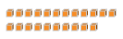
(Image Name: onesblocks2)

Step 5
The sum of the blocks in one blue box and the sum of the remainder blocks represents the quotient.

