Frame 01-01.01:

http://eportal.education2020.com/Curriculum/Production Library/frame-building-files/common/interactiveFrames/intervention/01-01/leftPanelTestFrame01-01.01.html
Step 1
Each tile represents 1. Drag tiles into the left rectangle to represent the first number in the problem, 4.
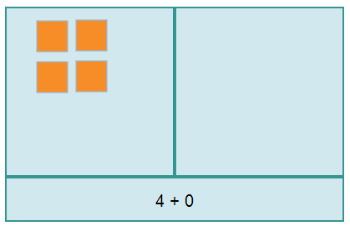
(Image Name: addend4)
Step 2
Drag tiles into the right rectangle to represent the second number in the problem, 3.
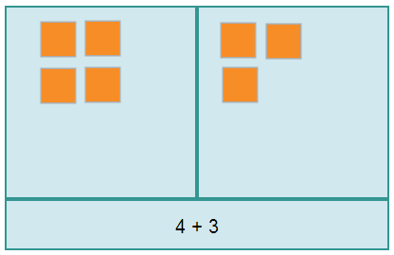

(Image Name: addend3)

Step 3
The bottom rectangle in the model shows the problem that is modeled by the tiles in the rectangles.
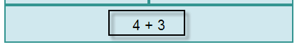
(Image Name: expression)
Step 4
When you are finished modeling the problem, count the number of tiles in the model. The total number of tiles represents the sum.
(no image)

Frame: 01-01.03:
http://eportal.education2020.com/Curriculum/Production Library/frame-building-files/common/interactiveFrames/intervention/01-01/leftPanelTestFrame01-01.03.html
Step 1
Model the sum using the top left and right rectangles. Since 13 is given, drag 13 tiles into the right rectangle to represent the given number on the left side of the equation.
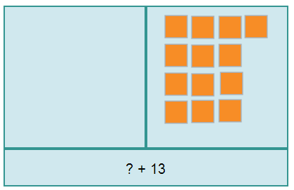

(Image Name: 13)

Step 2
Drag tiles one by one into the left rectangle, counting up until the total number of tiles in the model equals the sum, 20.
(no image)
Step 3
When you finished modeling a sum of 20, count the number of tiles in the left rectangle. The number of tiles in left rectangle represents the unknown number.
(no image)

