Frame 01-05.01:
http://eportal.education2020.com/Curriculum/Production%20Library/frame-building-files/common/interactiveFrames/intervention/01-05/leftPanelTestFrame01-05.01.html
Step 1
A column is a vertical group of tiles and a row is a horizontal group of tiles. An array is an ordered arrangement of columns and rows.
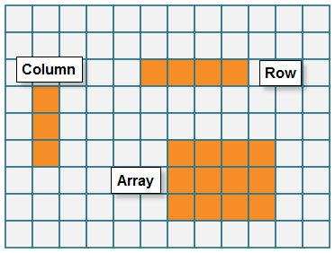
(Image Name: Array_Definition)
Step 2
Create the array using the first factor, 5, to represent the number of rows and the second factor, 2, to represent the number of columns.
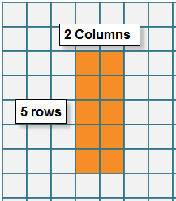 OR 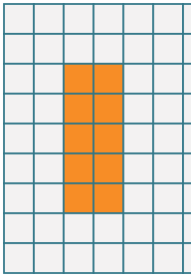
(Image Name: 5rows_2columns) (Image Name: 5x2_NoLabels)

Step 3
Count the total number of tiles. The total number of tiles in the array represents the product.
(no image)

Frame 01-05.02:
http://eportal.education2020.com/Curriculum/Production Library/frame-building-files/common/interactiveFrames/intervention/01-05/leftPanelTestFrame01-05.02.html
Step 1
A column is a vertical group of tiles and a row is a horizontal group of tiles. An array is an ordered arrangement of columns and rows.
(Image Name: Array_Definition)
Step 2
Click or tap 3 vertical tiles to represent 3 rows since adding tiles to the right or left of each tile will create a horizontal group of tiles.
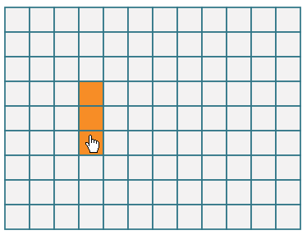
(Image Name: 3_Rows)
Step 3
Counting up, click or tap tiles in each row until the total number of tiles is 15. Each row will have an equal amount of tiles creating a rectangle.
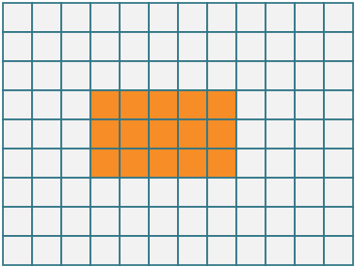
(Image Name: 15_Total)

