Frame 01-06.01:
http://eportal.education2020.com/Curriculum/Production Library/frame-building-files/common/interactiveFrames/intervention/01-06/leftPanelTestFrame01-06.01.html
Help (appears after student makes the groups of 6)
Drag five groups of 6 into the blue box to represent adding 6 to itself five times.
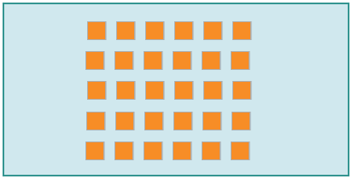
(Image Name: 5_Groups_of_6)

Frame 01-06.03:
http://eportal.education2020.com/Curriculum/Production Library/frame-building-files/common/interactiveFrames/intervention/01-06/leftPanelTestFrame01-06.03.html
Help (appears after student makes the 5 groups)
A blue box represents 1 group. Drag a tile into each group one by one until all tiles are used and each group has an equal number of tiles.
*The interactive needs to be fixed to get the image.

Frame 01-06.04:
http://eportal.education2020.com/Curriculum/Production Library/frame-building-files/common/interactiveFrames/intervention/01-06/leftPanelTestFrame01-06.04.html

Help (appears after student makes the group of 7 tiles)
Drag each group of 7 into an empty blue box until no groups remain.
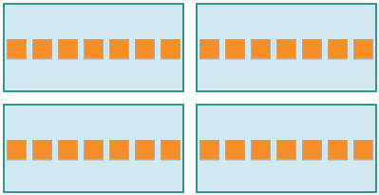
(Image Name: 4_of_7groups)

