Note: these frames are in steps and students must check after each step. A problem is that students are not seeing the prompt of the steps changing in the instructions. Interesting to create a help…

Frame 01-14.01
Step 1
Here there are two sets of whole number place values from thousands to ones. Two numbers total can be modeled, one in each row.
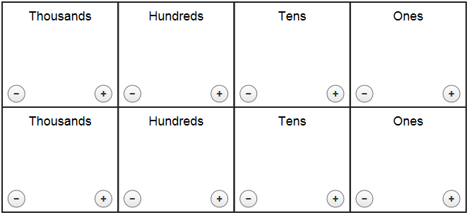
(Image Name: modelingplacevalue)

Step 2
Use the + and – buttons to add or remove base ten blocks.. For example, 2 and 3 are modeled in the image below.
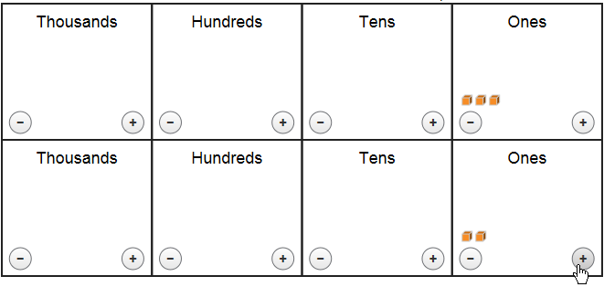
(Image Name: 3and2model)

Step 3
The numbers you model are shown in the sum area.
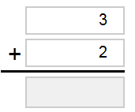
(Image Name: additionproblem)

Step 4
Use < to combine blocks into a bigger block. Use > to break a block into smaller pieces.
or 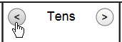
(Image Name: all_regroup_arrows) (Image Name: regroup_arrows)

Step 5
Enter the sum into the space below the equals bar.
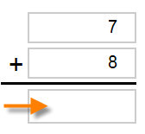 OR 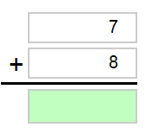
(Image Name: entersumarrow) (Image Name: entersumhighlight)

OR this image to be consistent with the 3 and 2 images…
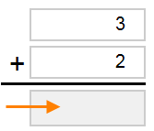 (Image name: 3and2sum) 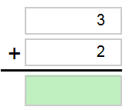 (Image name: 3and2highlight)
Frame 01-14.02
Step 1
Look at the model. There are two sets of whole number place values from one to thousands. Two numbers total can be modeled, one in each row.
(Image Name: modelingplacevalue)

Step 2
Use the + and - buttons to add or remove base ten blocks to model each number. For example, 14 and 32 are modeled in the image below.
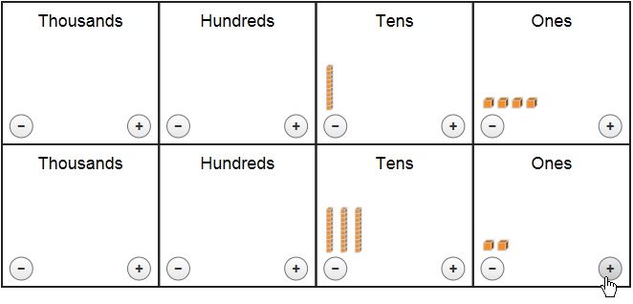
(Image Name: 14and32model)

Step 3
The numbers modeled are shown as the addends in the problem.
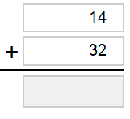
(Image Name: 14and32expression)

Step 4
Enter the sum of the addition problem below the equals bar.
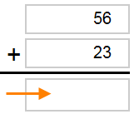 OR 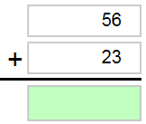
(Image Name: sumarrow) (Image Name: sumhighlight)

OR this image to be consistent with the 14 and 32 images…
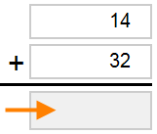 (Image name: 14and32arrow) 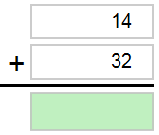 (Image name: 14and32hightlight)

Frame 01-14.03
Step 1
Look at the model. There are two sets of whole number place values from one to thousands. Two numbers total can be modeled, one in each row.
(Image Name: modelingplacevalue)

Step 2
Use the + and - buttons to add or remove base ten blocks to model each number. For example, 14 and 32 are modeled in the image below.
(Image Name: 14and32model)

Step 3
The numbers modeled are shown as the addends in the problem.
(Image Name: 14and32expression)

Step 4
Use the < button to combine blocks to create a bigger unit and > to break a unit into smaller pieces.
or
(Image Name: all_regroup_arrows) (Image Name: regroup_arrows)

Step 5
Enter the sum of the addition problem below the equals bar.
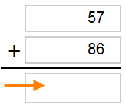 OR 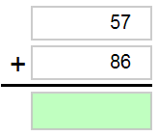
(Image Name: 57and86arrow) (Image Name: 57and86highlight)

OR this image to be consistent with the 14 and 32 images…
(Image name: 14and32arrow) (Image name: 14and32hightlight)

